No.1

(a)

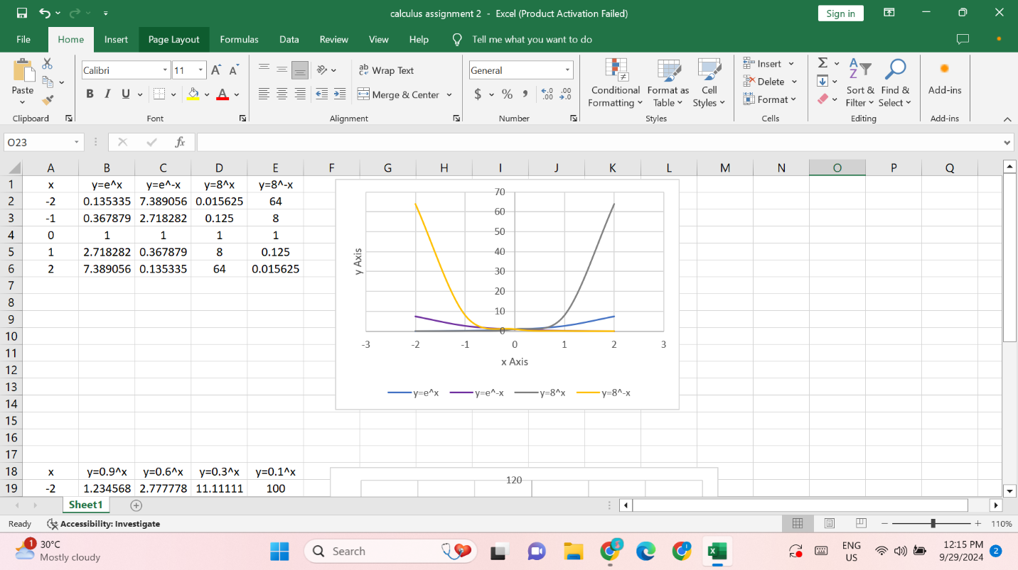

(b)

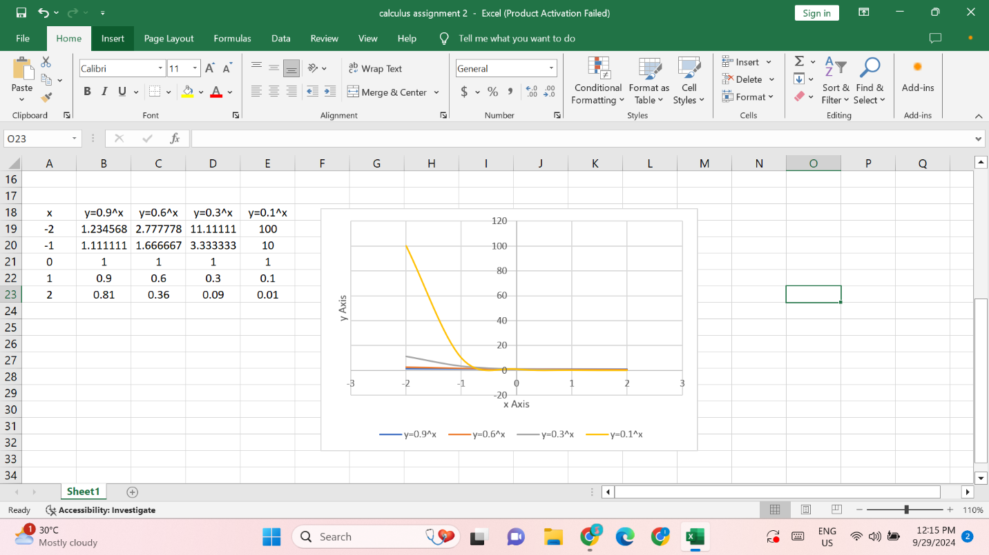

No.2

f(x)=10x

=

=

10x ( ) =

=

So, = 10x ( )

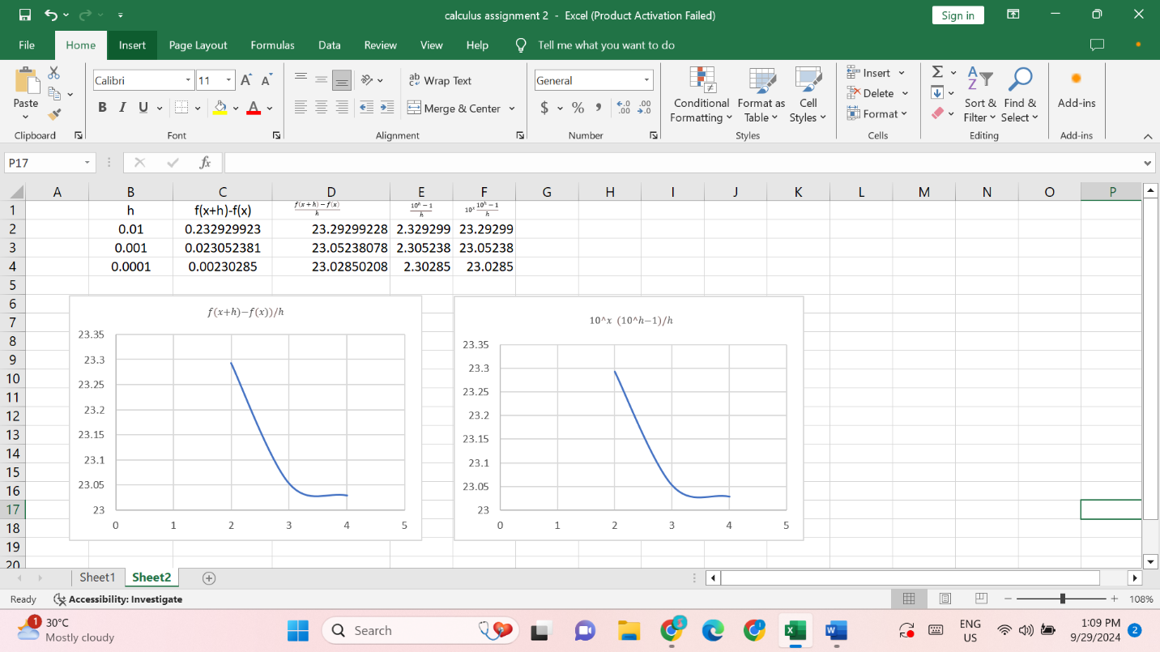

No.3

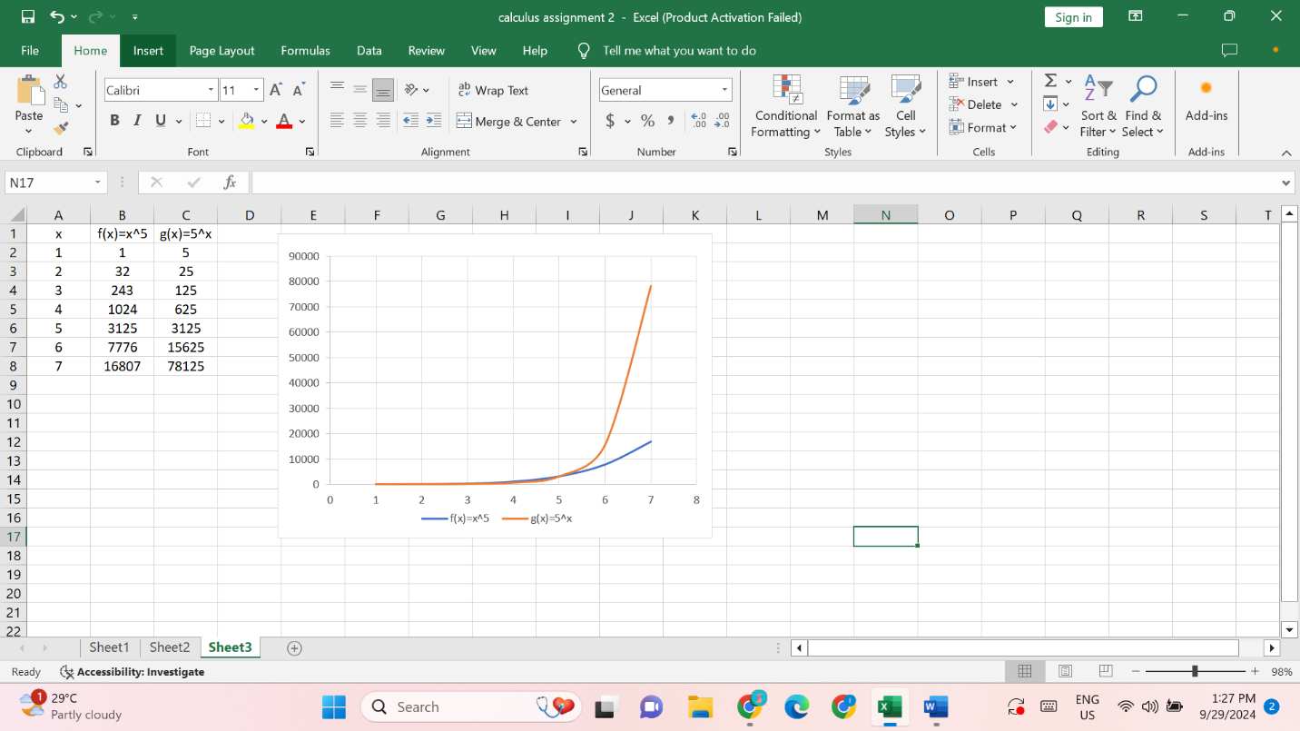

f(x)=x5 g(x)=5x

f(1)=15=1 g(1)=51=5

f(2)=25=32 g(2)=52=25

f(3)=35=243 g(3)=53=125

f(4)=45=1024 g(4)=54=625

f(5)=55=3125 g(5)=55=3125

f(6)=65=7776 g(6)=56=15625

No4.

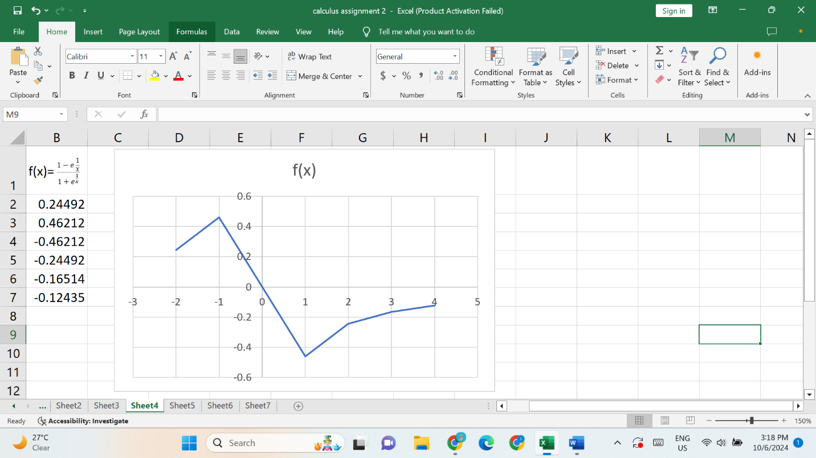

f(x) =

if f(-x) =

=

=

=

=

= -

= -f(x)

So, f(x) is an odd function.

No.5

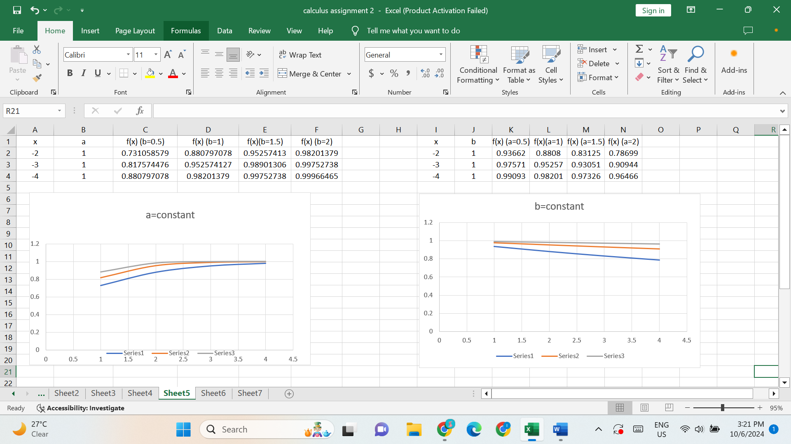

No.6

g(x)=x6+x4

y= x6+x4

To find the inverse of g-1(x), we will express x in terms of y. However, the 6th degree polynomial is very complex and it is impossible to write down an exact algebraic expression for g-1(x).

No.7

(a)

Q(t)=Q0(1-)

= 1-

= 1-

= ln (1- )

t= -a ln (1- )

t(Q) = -a ln(1- )

The time t takes to accumulate a certain amount of charge Q in the capacitor to reach the charge level.

(b)

When a=2, Q=90%

t= -2 ln(1- 0.9)

t= -2ln(0.1)

t= -2(-2.3026) while ln(0.1)= -2.3026

t= 4.6052 seconds

